ELECTROCHEMICAL PROPERTIES OF PRUSSIAN BLUE-POLYPYRROLE COMPOSITE
^{1,2}Nataliia Talagaeva, ^{1,2,3}Ekaterina Zolotukhina, ^{1,2,3}Mikhail Vorotyntsev
¹The Institute of Problems of Chemical Physics RAS, Chernogolovka, Russia; E-mail: talagaevanv@gmail.com
²D. Mendeleev Russian University of Chemical Technology, Moscow, Russia
³Lomonosov Moscow State University, Moscow, Russia
Introduction
Prussian Blue (PB) is a promising material for electrocatalytic application (H₂O₂, glucose, SO₃²⁻ sensors) nevertheless attracts little attention as an electrocatalyst because of fast degradation of its electrocatalytic properties, mostly due to peeling off fragments of the electroactive film from the substrate. One of the ways to solve this problem is to create any composite material based on matrix for PB particles (conductive polymers affect stabilizing are often used). It is important to select the synthesis conditions permit to obtain the most stable composite films PB-polypyrrole (PPy) on the surface of inert electrode for electrocatalytic application.
Experiments
PB-PPy composites were generated via a one-pot one-step redox reaction between the oxidizer (equimolar mixture of iron(III) and ferricyanide salts) and the reducing agent (pyrrole, Py, taken in excess) in their mixed aqueous solution, with addition of a background electrolyte. It was found that the anion type in the synthetic mixture strongly affects the characteristics of deposited composite films [1,2]. For the further experiments the nitrate background solution was selected as the use of this one results in high quality films without cracks [2].
The concentrations of PB and PPy precursors in the synthetic mixture were varied. PB-PPy films were deposited from reaction mixtures with 0.1 mM Fe³⁺, 0.1 mM [Fe(CN)₆]³⁻, and 0.5 mM Py (system 1:1:5); 0.1 mM Fe³⁺, 0.1 mM [Fe(CN)₆]³⁻, and 1.0 mM Py (system 1:1:10); 0.5 mM Fe³⁺, 0.5 mM [Fe(CN)₆]³⁻, and 0.5 mM Py (system 1:1:1); and 0.5 mM Fe³⁺, 0.5 mM [Fe(CN)₆]³⁻, and 1.0 mM Py (system 1:1:2). PB-PPy composite was deposited at the surface of Pt and ITO-coated glass working electrodes. To modify the electrode surface with PB-PPy film, the electrode was placed in reaction mixture for 48 h and then rinsed thoroughly with distilled water.
Electrochemical measurements were performed in single-compartment three-electrode cell with coiled Pt wire as counter electrode and Ag/AgCl as reference electrode. Redox activity of PB modified electrodes related to reversible transformation of PB to PW due to reduction of Fe(III) ions inside the PB lattice was characterized by cyclic voltammetry (CV). Stability tests of composite films were carried out either under conditions of the hydrogen peroxide electroreduction and sulfite electrooxidation or in the course of multi-cycle experiments. The film-coated electrode was subjected to such repeating CV treatment until the cathodic (or anodic) charge of the cycle has become lower than 25–30 % of the charge of the second cycle. Electrochemical measurements were carried out at room temperature. Redox activity of synthesized PB-PPy composites immobilized on electrode surface was tested in the same nitrate background electrolyte which was used for their synthesis. Tests of the electrocatalytic activity of PB-PPy films in H₂O₂ and Na₂SO₃ solutions were performed with the use of potassium phosphate buffer (pH 6.0). Electroreduction of hydrogen peroxide and electrooxidation of sulfite anions at these modified electrodes were performed in potentiostatic conditions.
Results and Discussion
The one-step method of the chemical deposition of PB-polypyrrole films on a conducting or insulating solid substrate (including an electrode surface) from the mixed solution of pyrrole, iron (III) and ferricyanide salts have been elaborated. It has been found that such films consist of composite particles where small PB single crystals are incorporated into PPy surrounding. It is important to mention that PB inside the composite film retains its crystalline structure even after its long-time functioning as electrocatalyst in 1 mM hydrogen peroxide solution, the size of PB crystals remaining unaffected (according to XRD spectra). It means that the progressive loss of its catalytic properties is not due to a progressive dissolution of the reduced form, PW. The stability period of the H₂O₂ electroreduction for nitrate-synthesized films on Pt substrate was about eighty times longer than that of pure Prussian Blue films without polymeric support.
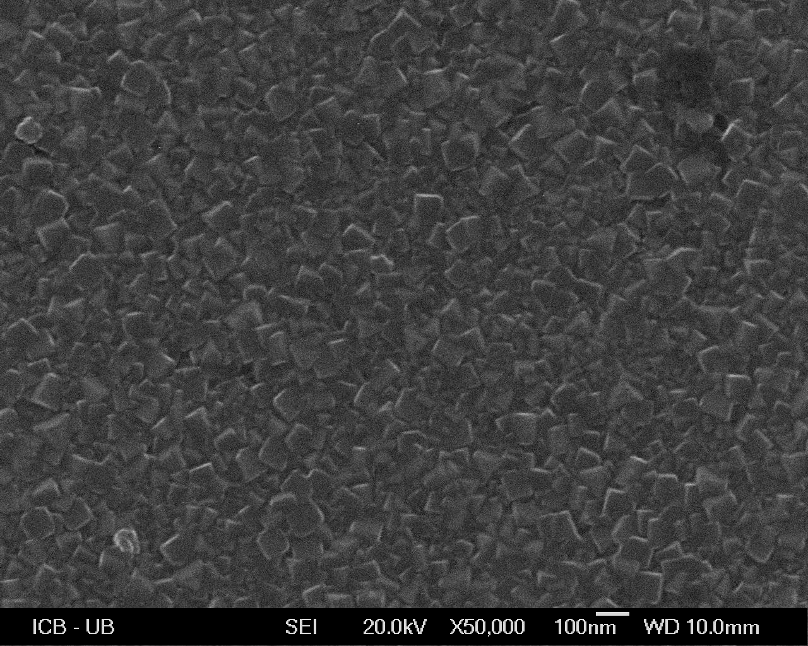
Figure 1. SEM image of PB-PPy composite films on ITO support obtained in nitrate electrolyte
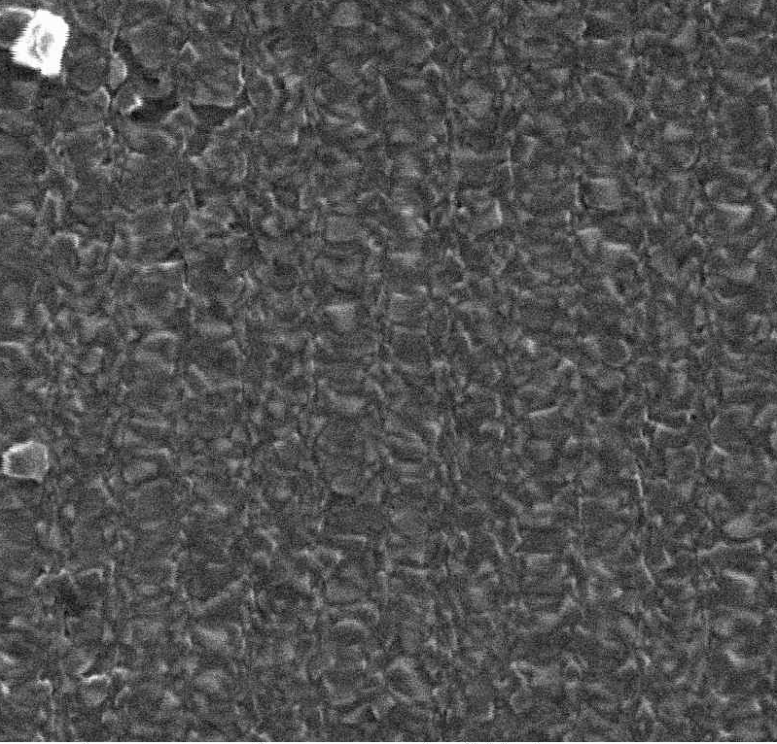
Figure 2. SEM images of PB-PPy films on ITO surface after electroreduction in 1 mM solution of H₂O₂
Table 1: Principal characteristics of Prussian blue–polypyrrole composite films
Composition of mixed solution | ”System” | Number of cycles performed, i | Degradation degree, χ_{i} (%)
0.1 mM [Fe³⁺ + Fe(CN)₆³⁻] + 0.5 mM Ру | 1:1:5 | 3000 | 25
0.1 mM [Fe³⁺ + Fe(CN)₆³⁻] + 1.0 mM Ру | 1:1:10 | 1600 | 9.5
0.5 mM [Fe³⁺ + Fe(CN)₆³⁻] + 0.5 mM Ру | 1:1:1 | 1700 | 30
0.5 mM [Fe³⁺ + Fe(CN)₆³⁻] + 1.0 mM Ру | 1:1:2 | 2000 | 30
So, composites based on PPy matrix demonstrate more stable electrochemical properties compared to pure PB (stability period of PB-PPy films is 10 times greater than that for pure PB films). Electrochemical stability of composite films depends on the amount of Py in synthetic solution. It was found that characteristics of PB-PPy films essentially depend on synthesis solution. Composite films formed via redox synthesis procedure from solution where molar ratio Fe³⁺:[Fe(CN)₆³⁻]:Ру was 1:1:10 and 1:1:5 with nitrate supporting electrolyte demonstrate the lowest degradation degree [3].
In the reaction of SO₃²⁻ electrooxidation electrochemical properties of composite films formed via redox synthesis procedure from solution with molar ratio Fe³⁺:[Fe(CN)₆³⁻]:Ру 1:1:5 were the most stable. Such films demonstrate electrocatalytic activity both in sulfite model solutions and in wine. It was shown that PB-PPy films synthesized on ITO electrodes demonstrate the similar to obtained by the use of titrimetric method results.
It was estimated that sensitivity coefficient and amperometric response stability of PB-PPy films in various electrochemical tests depend on not only component ratio in film but also on adhesion of composite film to electrode surface.
Acknowledgments
This work was supported by the RFBR (project no. 15-03-06351 A).
References
1. Itaya K., Uchida I. Nature of Intervalence Charge-Transfer Bands in Prussian Blues // Inorg. Chem. 1986. V. 25. P. 389-392.
2. Talagaeva N.V., Zolotukhina E.V., Bezverkhyy I., Konev D.V., Lacroute Y., Maksimova E.Y., Koryakin S.L., Vorotyntsev M.A. Stability of Prussian blue–polypyrrole (PB/PPy) composite films synthesized via one-step redox-reaction procedure // J. Solid State Electrochem. 2015. V. 19. P. 2701–2709.
3. Talagaeva N.V., Zolotukhina E.V., Pisareva P.A., Vorotyntsev M.A. Electrochromic properties of Prussian blue–polypyrrole composite films in dependence on parameters of synthetic procedure // J. Solid State Electrochem. 2016. V. 20. P. 1235–1240.

