STRUCTURAL AND DYNAMIC FEATURES OF CALIXARENESULPHOIC ACIDS INVESTIGATION BY NMR
¹ Alexander Chernyak, ² Nikita Slesarenko
¹ Institute of Problems of Chemical Physics of RAS; Science Center in Chernogolovka RAS, Chernogolovka, Russia, E-mail: sasha_cherniak@mail.ru
² Institute of Problems of Chemical Physics RAS, Chernogolovka, Russia, E-mail: wownik007@mail.ru
Introduction
The possibility of creating calixarenes with so-called "host-guest" structures is widely studied. Calixarene can capture molecules of different sizes depending on the size of the cycle and the nature of the substituents in the lower and upper rim. It has recently been found that the calix[n]arene sulfonic acids form of layered structures. The inorganic layer is formed by hydrated sulfonated group SO₃H⁺(H₂O)_{m}, forming a three-dimensional network of hydrogen bonds, over which rapid transfer of hydrogen ions is possible. It has been shown that calix[n]arene sulfonic acids (n = 4, 6, 8) [1] have record values of proton conductivity among solid electrolytes - up to 0.1 S/cm. It has also been shown that calix[4]arene sulfonic acid is capable of capturing molecules of gases such as CO₂, N₂, O₂ into the cavity, but passing hydrogen. It is suggested [2] to use it to separate hydrogen from the gas mixture. However, calix[4]arenes sulfonic acid is not suitable for use in pure fuel cells due to the hydrogen crossover. It is assumed that it will possible to avoid the crossover of hydrogen if occupying the cavity by suitable molecules. In our presentation, complexes of calix[4]arene sulfonic acid with acids CH₃COOH, CF₃COOH, CCl₃COOH were investigated. It is quite possible to form stable complexes of acids with calix[n]arene molecules due to the formation of strong intermolecular hydrogen bonds. The aim of the work is to study the processes of self-diffusion and hydration in calix[n]arene sulfonic acids and complexes based on them at different moisture contents and different cycle sizes.
Experiments
The investigations were carried out by high resolution NMR, NMR with pulsed-field gradient (PFG NMR) and magic angle spinning NMR (MAS NMR) techniques. High-resolution spectra were recorded on the AVANCE III 500MHz Bruker spectrometer of the analytical center of Institute of Problems of Chemical Physics RAS. Diffusion and MAS NMR experiments were carried out on the AVANCE III 400MHz Bruker spectrometer of the analytical center of Science Center in Chernogolovka RAS. The spectrometer is equipped with a diff-60 diffusion unit with the ability to create a magnetic field gradient up to 30 T/m.
Results and discussion
The processes of hydration and self-diffusion of calix[n]arene sulfonic acids (n = 4, 6, 8) were studied. Self-diffusion coefficients (CSD) on ¹H nuclei were measured by PFG NMR. Spin - echo signal attenuations on gradient pulsed amplitude curves (diffusion decays) show a complex non-exponential shape (Fig. 1). This indicates the presence of several phases with different proton mobility.
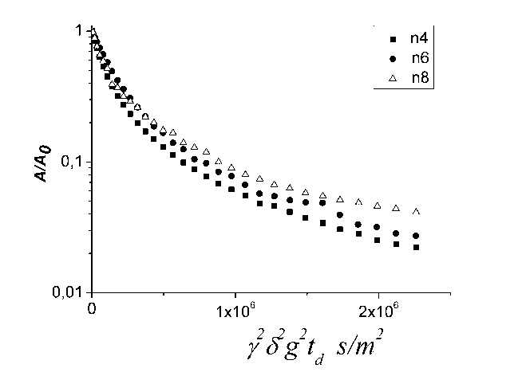
Figure 1. Diffusion decay of SO3H-Calix[n]arene (RH=32%)
The data obtained by means of impedance spectroscopy were compared with the results of self-diffusion in the framework of the Nernst-Einstein relation. The average CSD, (D_{s}^{av}.) was used for the calculations. A good agreement between experimentally measured conductivity and conductivity calculated from self-diffusion coefficients was found. The temperature dependences of CSD for calix[4]arenes sulfonic acids at different moisture have been approximated by Arrhenius equations with an activation energy of 0.18-0.23 eV, which agrees well with the activation energy of proton conduction. Figure 2 shows the temperature dependences of the average CSD D_{s}^{av} for various water content λ (the number of water molecules per SO₃H group).
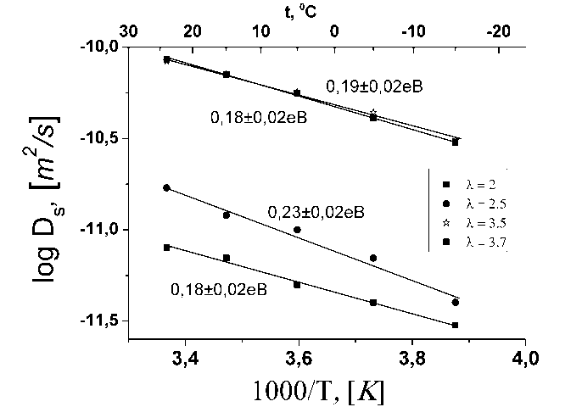
Figure 2. Temperature dependences of D_{s}^{av} Calix[4]arene-SO3H for different λ.
The aim of the second part of the work was to obtain complexes based on Calix[4]arene-SO₃H with organic acids CH₃COOH, CF₃COOH, CCl₃COOH. The high-resolution NMR unambiguously shows the formation of a calix[4]arene sulfonic acid complex with acetic acid 1:1 by moles. The formation of complexes with CF₃COOH and CCl₃COOH acids confirmed indirectly by high resolution NMR and MAS NMR techniques. MAS NMR spectra analysis showed that with moisture increasing, the acids molecules of low molecular weight are partially released from the calixarene cavity and do not "come back" upon subsequent drying. The same conclusions were obtained by comparing the CSD of the received complexes. Thus, with a low water content (while the acids are still located in the calixarene cavity), lower CSD are observed compared to pure calix[4]arene sulfonic acid. And with the increase in the number of water per sulfonated group, their CSD equalized in magnitude. Thus, the acid CH₃COOH, CF₃COOH, CCl₃COOH form complexes with the calix[4]rene sulfonic acid, there is a slight decrease in ion mobility in the system. With an increase in the amount of water per sulfone group (>3.5 moles of H₂O/SO₃H), low molecular weight organic acids are partially displaced from the cavity of calixarene and the CSD become equal to the CSD of the pure calix[4]arene sulfonic acid.
This work was supported by Russian Foundation for Basic Research (projects No. 18-08-00423 A
References
1. L. Shmygleva, N. Slesarenko, A. Chernyak, E. Sanginov , A. Karelin , A. Pisareva, R. Pisarev, Yu. Dobrovolsky Effect of Calixarene Sulfonic Acids Hydration on Their Proton Transport Properties // Int. J. Electrochem. Sci. 2017. V.12. p. 4056 – 4076
2. J.L. Atwood, L.J. Barbour, A. Jerga, Angew. // Chem. Int. Ed. 2004. V.43. p.2948–2950

