Membrane cascade type of "сontinuous membrane column"

Artem A. Atlaskin, Maxim M. Trubyanov, Pavel N. Drozdov, Ilya V. Vorotyntsev, Vladimir M. Vorotyntsev

Nizhny Novgorod State Technical University n.a. R.E. Alekseev, Nizhny Novgorod, Russia,

*E-mail: atlaskin@gmail.com*

Introduction

Strengthening of environmental regulations, improvement of product specification level, and the need to reduce production costs in the current economic situation set the task for chemical engineers to intensify the implementation of energy-efficient separation methods and search for novel ways of optimizing the existing technological solutions. Membrane gas separation has recently drawn a great attention in the field of high-purity gases production in conjunction with developing continuous non-waste technologies capable to provide small-scale point-of-use supply of high-purity gases. It has been shown that new single-stage schemes, such as unsteady-state membrane gas separation[1] and absorbing pervaporation[2] have a great potential in gas separation applications, but the separation efficiency of the single stage membrane processes is limited by the selectivity of the membrane at a given pressure ratio, hence the high purity product can be obtained only by multi-stage systems. However, this leads to a material-intensive configurations and high capital costs, which makes the membrane process noncompetitive. Another approach to increase the separation efficiency is the use of a continuous membrane column[3,4] which has similar configuration to a distillation column. The purpose of the current work is to present novel concepts for realization of purification process by gas separation in multi-stage membrane cascades which are promising and competitive prototypes of countercurrent distillation columns.

Experiments

Gases high purification experiments were carried out using the set-up presented at Fig. 1. The gas flow direction is indicated by arrows. This membrane cascade consists of three membrane elements: single module for extraction section and two elements in enrichment section.

Gas mixture composition determination was carried out by gas chromatography, using helium carrier gas, a thermal conductivity detector and a Porapak Q packed column.

In the experiments an argon-propane model mixture was used with concentration 0.02 – 1% of propane.



Figure 1. Principal scheme of membrane cascade type of «continuous membrane column»

Results and Discussion

A cascade of the membrane column (MC) type is shown in Fig. 2a, and a cascade of the three-module membrane column (TMC) type is shown in Fig. 2b. Fig. 2c presents the scheme of a two-membrane column (TwMC) in which the membranes in the elements in both section have opposite properties, in contrast to the preceding cascades: the contaminant passes through the membrane better than the basic component in the extraction section and worse in the enrichment section.

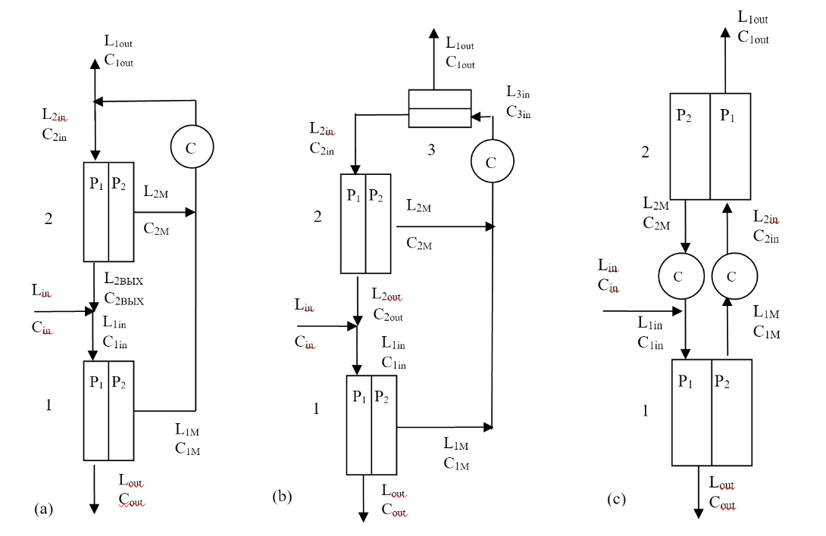

Figure2. Diagram of MC (a), TMC (b), and TwMC (c) cascades. K, compressor; P1, HPC; P2, LPC.

The cascade separation efficiency as a function of stage-cut (𝜃) is presented in Fig. 3, where are F1 is extraction section separation factor, F2 enrichment section separation factor and F is the set-up separation factor. Separation factor of extraction and enrichment sections is determined by the inlet and outlet gas mixture concentration ratio. Cascade separation factor is the ratio of impurity concentration in impurity fraction and product fraction.

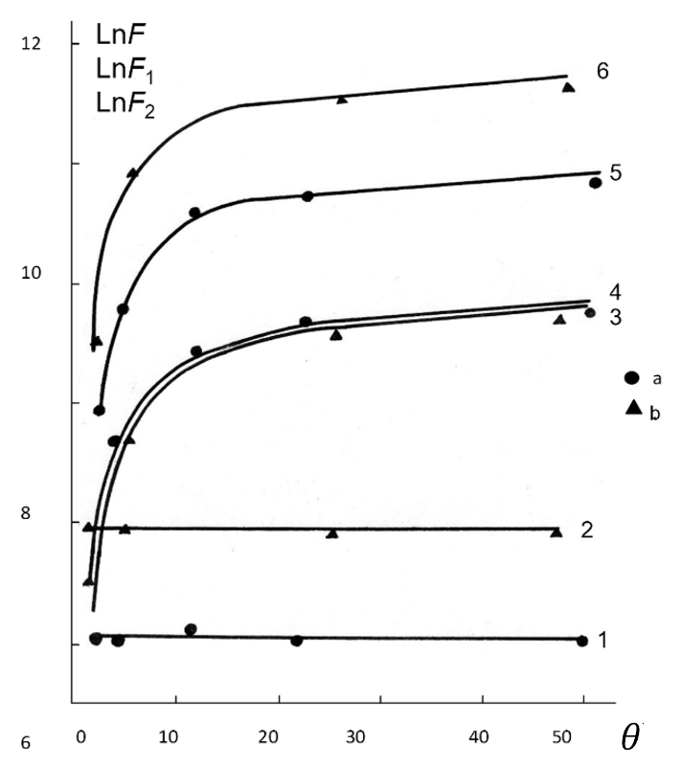

Figure 3. The dependence of the separation factor of the extraction section (F1), enrichment section (F2), and the setup as a whole (F) on the parameter 𝜃 = l1/l0: (a) experimental data for the MC mode; (b) TMC mode: (1, 2) F2; (3, 4) F1; (5, 6) F.

It is shown that with an increase of stage-cut value (or with a decrease in the rate of product and concentrate withdrawal), the separation efficiency of the extraction section increases, and its value for the enrichment section varies insignificantly. The separation factor of the set-up is also increasing. The degree of separation of the enrichment section of the TMC-type cascade is higher than that of the MC-type cascade. The degree of separation of the extraction section of the cascades of both types is practically the same. A small difference is explained by a decrease in the withdrawal degree of the concentrate and, correspondingly, an increase in the withdrawal rate of the purified product in a cascade of the TMC type in comparison with MC for the same stage-cut value parameter.

The experimental results are in good agreement with the calculated data. The maximum separation factor is 1.8 ∙ 104 in the MC cascade and 8.5 ∙ 104 in the TMC cascade is obtained. The degree of product withdrawal is 87% and 98%, respectively. In the same case, without the enrichment section, the degree of product withdrawal does not exceed 2%. Thus, it was shown that this design of the membrane cascade apparatus has great potential for use in gases high purification applications and it does not require a large number of membrane elements and compressors to achieve a high degree of purity of the product in contrast to the cascade schemes proposed earlier.

**References**

1. M.M. Trubyanov et al. / Journal of Membrane Science 530 (2017) 53 – 64
2. I.V. Vorotyntsev et al. / Desalination and Water Treatment (2017) 1 – 9. doi: 10.5004/dwt.2017.20400
3. V.M. Vorotyntsev et al. / Desalination 147 (2002) 433 – 438
4. V.M. Vorotyntsev et al. / Separation and Purification Technology 22 (2001) 367 – 376

**Acknowledgements**

This work was supported by the grant of the President of the Russian Federation (MD-5414.2016.8), and the Russian Foundation of Basic Research (16-38-60174 mol_a_dk).