DEOXYGENATION OF HIGH-PURITY WATER USING MEMBRANE ELECTRODE UNITS
I.M. Yasnev, V.S. Gurskiy
Aleksandrov Research Institute of Technology, Sosnovyi Bor, Russia

Dissolved oxygen is a crucial factor of corrosion in the thermal and nuclear power energetics. Significant corrosion rate reduction can be achieved if dissolved oxygen level in the water is at 20 ppb or less. The raise of dissolved oxygen level from 20 to 100 ppb increases corrosion rate by 10 times.
The research of transport processes of substances through the ion exchange membranes coated with electronically conducting layers was made, resulting in using this kind of systems for electrochemical oxidation and reduction of substances on the surface of catalytic electronically conducting layers. A membrane electrode unit (MEU) were constructed . It is a cation exchange membrane whose surfaces are coated with a porous electronically conducting metal layer. This structure allows user to carry out a current drainage (electron conduction of surface) and doesn’t prevent electrode reaction on the interphase boundary membrane/porous metal and ion transport through this boundary.
The proposed scheme of water deoxygenation is shown in Fig. 1.
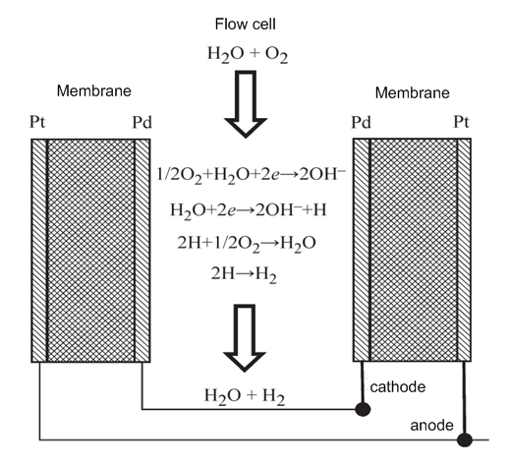
The flow cell is a space restricted from both sides with a cation exchange membrane with surfaces coated with porous layer of catalytically active metal (platinum, palladium). Metal layers facing into the cell are cathode, the outer layers are anode. When water flows through the cell and electric field is applied, the next electrochemical reaction is occurring on the cathode:
ionization of the dissolved oxygen
½ O₂ + H₂O + 2e → 2 OH–, (1)
generation of the atomic hydrogen
H₂O + 2e → 2 OH– + H. (2)
Atomic hydrogen reacts with dissolved oxygen on the catalytic surface, with water as the resultant. Due to these processes, concentration of dissolved oxygen is decreasing.
On the anode of MEU the discharge reaction of water from the membrane occurs with generation of the gaseous oxygen. The high permeability of the ion exchange membrane to water allows conducting the electrolysis process with the "dry" anode cell.
An important fact is that the water electrical resistivity at the unit doesn’t affect the voltage-current characteristic of the electrode processes, because it is determined primarily by the electrical resistivity of the ion exchange membrane. Therefore, this method can be applied to deoxygenation of high purity water with high electrical resistivity.
Due to diffusion limits of dissolved oxygen transport to the surface of membrane, part of the atomic hydrogen formed on the cathode does not react with oxygen, recombines to molecules and washes out with water flow. Complete removal of dissolved oxygen occurs in the catalytic column, whose surface is covered with a catalytic layer of palladium, and which is filled with the anion exchange resin.
The obtained results allowed constructing a pilot sample system for high-purity water deoxygenation. This system contains devices monitoring the quality of feeding and finish water (conductivity, dissolved oxygen). System of electromagnetic valves switches the water flow with indication of analyzers. It provides automatic shutdown of the output water flow from the consumer then quality of water become worse. The system can be operated in automatic or manual mode.
Specifications of a setup shown in Table 1
Table 1.
Productivity, L·h⁻¹ | 500
Readiness time, min | less 30
Concentration of the dissolved oxygen, mg·L⁻¹  Input water flow  Output water flow | 10  less 0.010
Conductivity, μSm·cm⁻¹:  Input water flow  Output water flow | less 2,0  less 0,2
Concentration of chlorides in output water flow, mg·L⁻¹ | less 0,01
Power supply | 220 V / 50 Hz
Size, width х depth х height, mm | 800х600х2000
Weight, kilograms | 120

Selected constructive solutions allow, if required, to increase productivity of the system up to 1000 L·h⁻¹ without significant changes of construction.
The advantages of system are:
- low power consumption (especially compared to thermal deaeration),
- mobility and easy maintenance operations;
- the use of reagents and inert gases is not necessary.

